Module 04
Aim : Software as a Service
Objective: Understand on demand application delivery and Virtual desktop infrastructure.
Technology: Ulteo
Theory:
Ulteo Open Virtual Desktop (OVD) is a delivery platform that provides on-demand access to private and public cloud hosted virtual desktops and supports Windows Remote Desktop Services and Linux hosted desktop and application sessions. OVD enables organizations to integrate and seamlessly deliver them as a secure service to clients based on Windows, Linux, MacOS, Android and IOS platforms. The challenge for IT is to deliver solutions that satisfy the increasing newly technological demands within their existing budget. Ulteo helps organizations respond to these challenges by providing a scalable and powerful infrastructure that enables IT to transform the way it delivers and manages desktops and applications helping the business to reduce the complexity and overheads associated with traditional delivery methods.
Key Benefits
- Transform IT Delivery:
Deliver hosted virtual desktops and applications on-demand.
- Reduce Complexity:
Simplify the process of desktop and application management and delivery.
- Lower Costs:
Reduced complexity leads to lower infrastructure costs. In addition Ulteo provides perpetual license free affordable software subscription plans.
Platform Features
- Open Architecture - Open source, open architecture, cross platform with Windows and Linux support, open to integration and perpetual license free!
- Simplicity - Feature rich and flexible platform with an easy-to-use seamless user experience
- Scalability - The OVD architecture has been designed for performance and scalability incorporating advanced server load balancing. Performance tuning and comprehensive testing of Windows and Linux application servers ensures efficient load handling and directory management.
- Hi-Def Delivery - The UxDA display protocol has been developed to deliver a rich user experience that parallels that of a local PC and supports the use of local peripherals such as printers and storage while being Microsoft RDP compatible.
Procedure:
OVD Virtual appliance works with both on VMware or VirtualBox. For easy setup, use a DHCP network with a bridged interface on your host machine configuration.
Following are the steps to use the Ulteo Open Virtual Desktop "Web Client", its capabilities and how to launch Ulteo OVD sessions using a web client:
Step 1: Open VMware.
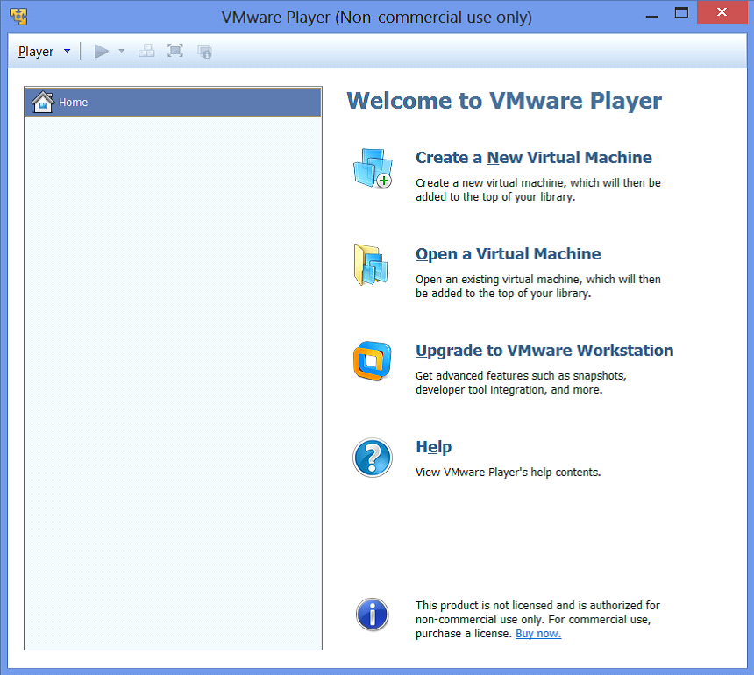

Step 2: Import OVA file into VMware.

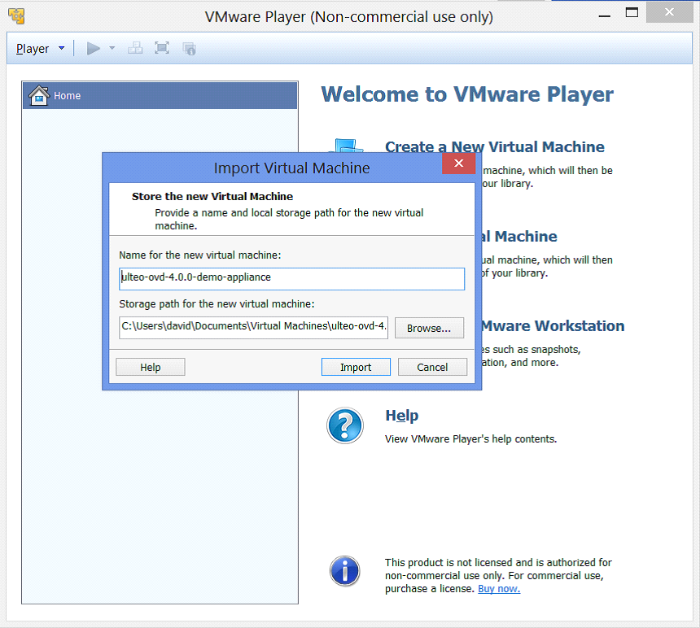
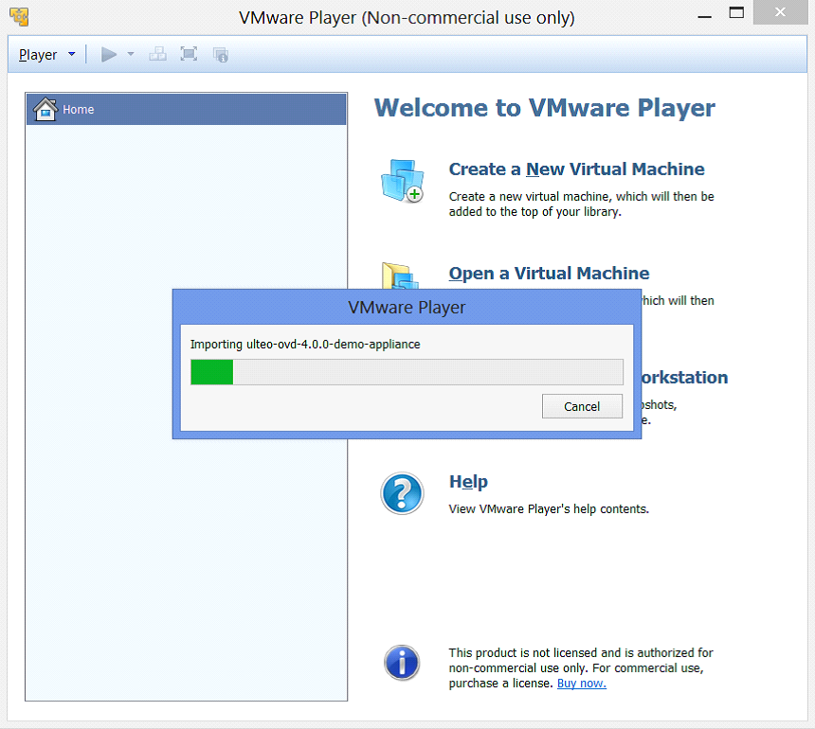

Step 3: Running the virtual appliance.
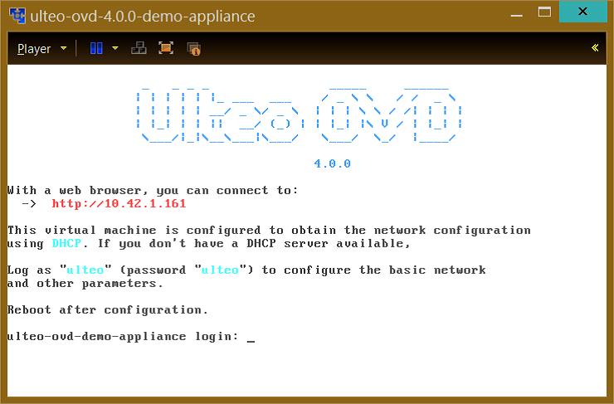
Step 4 : Open a we browser and access URL provided by ulteo-appliance. Here it is: http://10.42.1.161

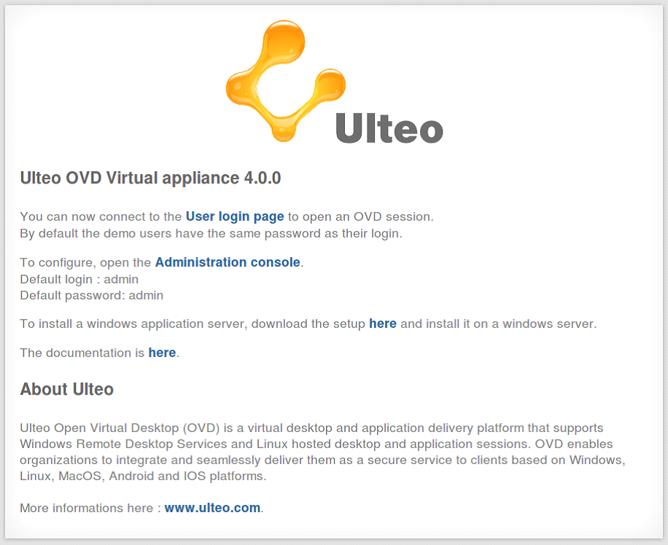

Step 5: Open the Administration Console, with username admin and password admin
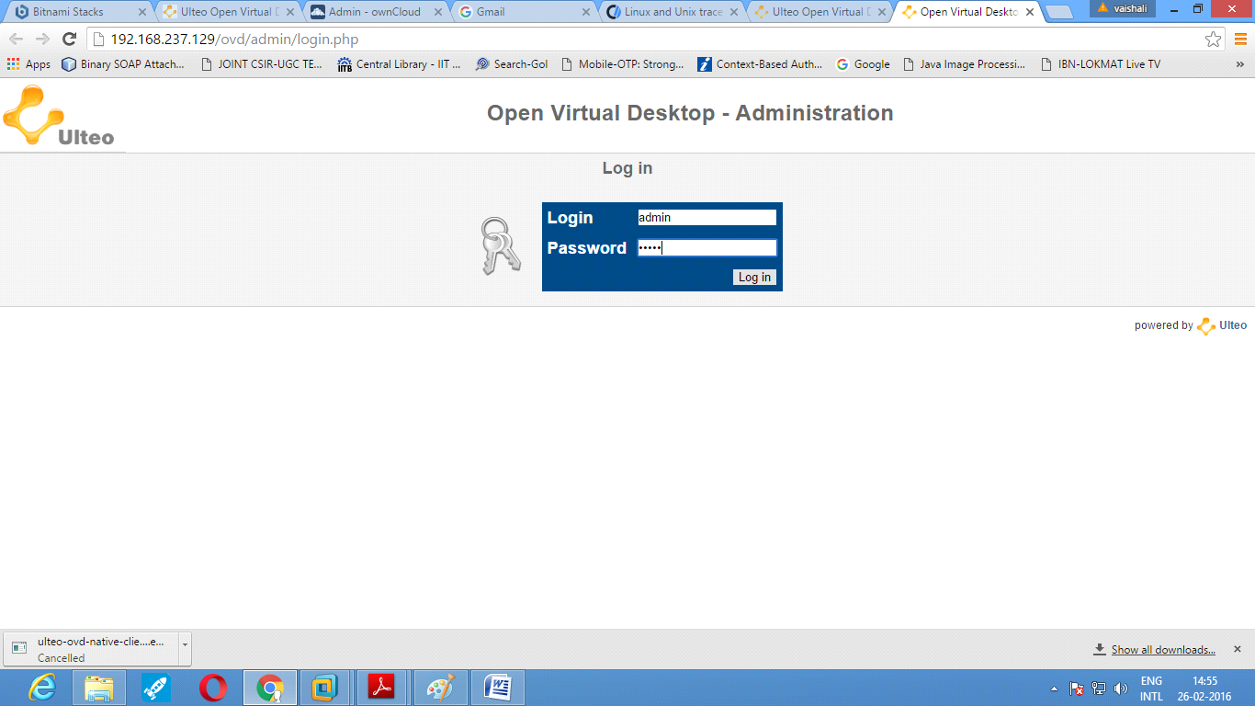
Step 6: Figure shows Home page of the Administration console. Edit the General configuration here.
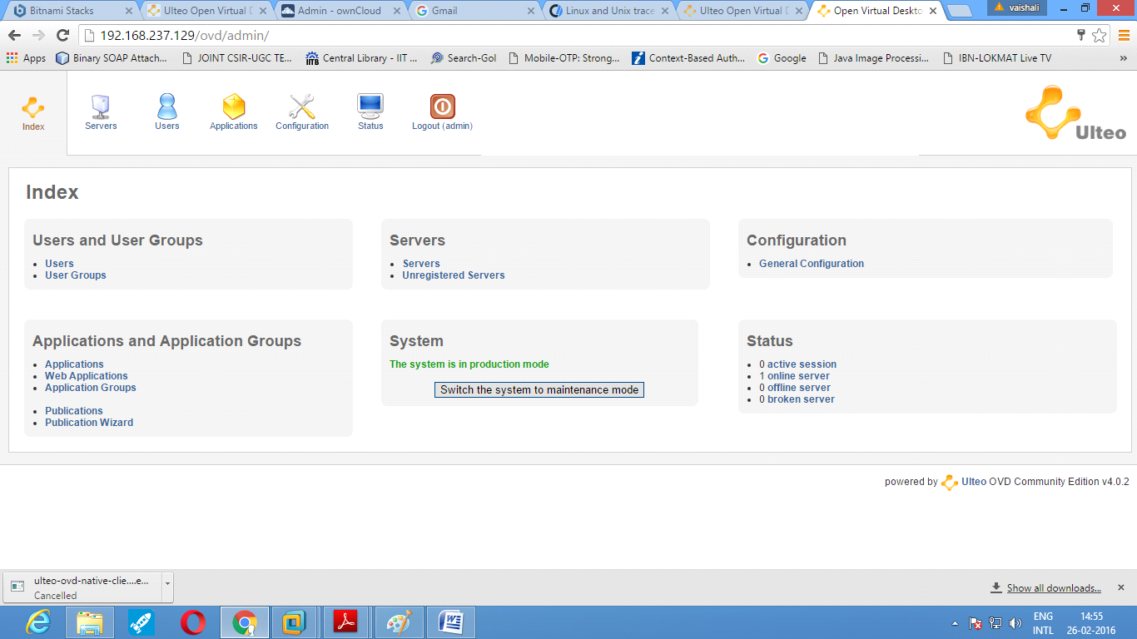
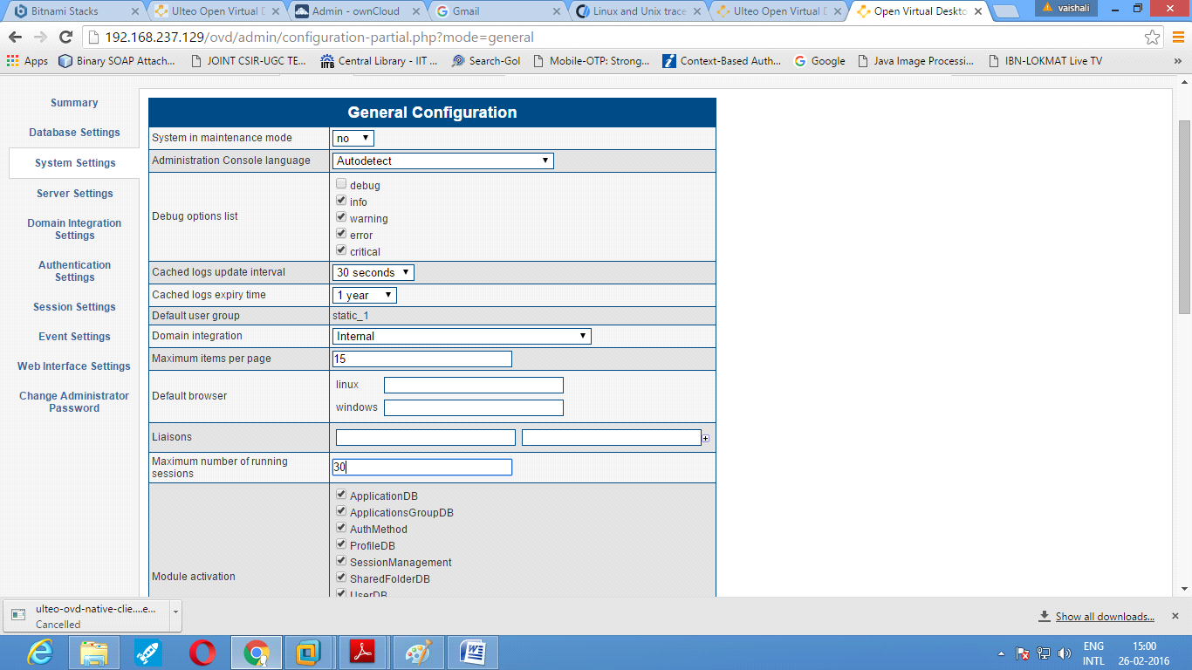
Step 7: To add user using Administration Console.
Note: Only 15 users are displayed by default. To view newly created user, we can delete few names from the existing list.
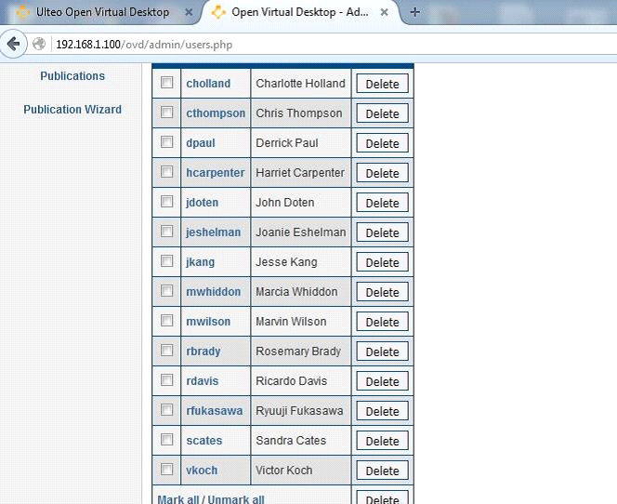

Step 8: Create User group.
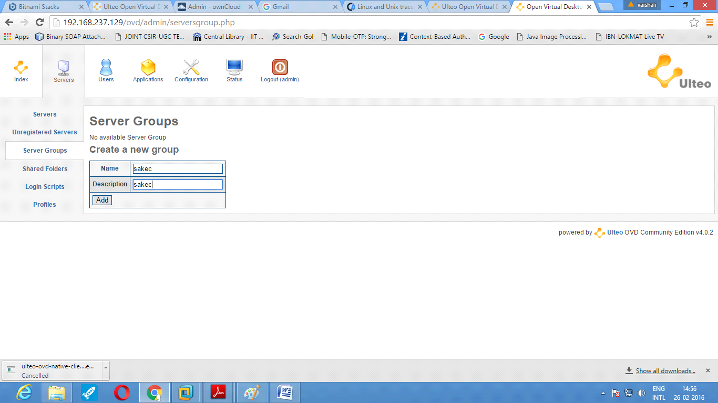
Step 9: Add users to the newly created groups.
Note: Use the "Add to this server" button to add the groups to the server.
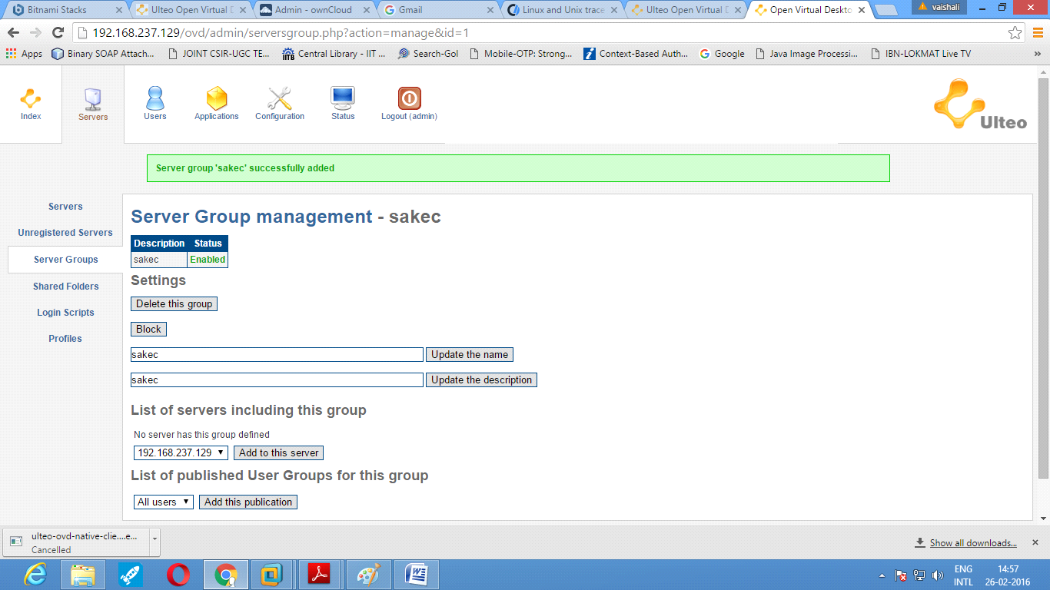

Step 10: Create Shared folder and assign the folder to the particular group.
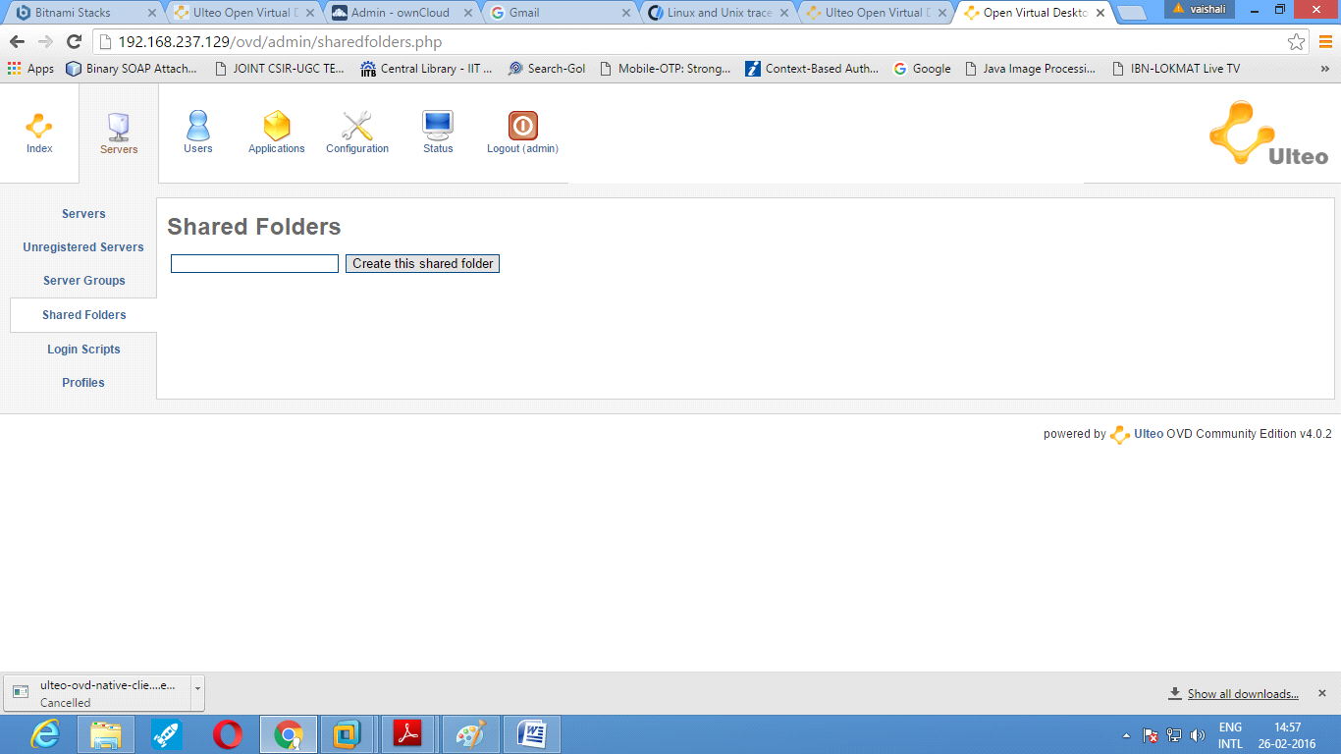
Note: You can view the shared folder by accessing User console from the home screen
Step 11: To create a staic application, install the application package. For example: vlc player.
a. Open Ulteo-ovd-appliance console and login as ulteo and password ulteo.
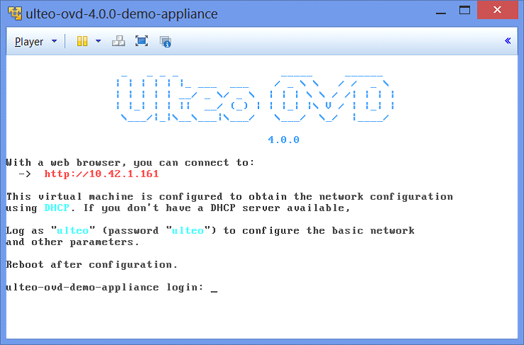
b. Select root console and install the package using sudo apt-get install vlc
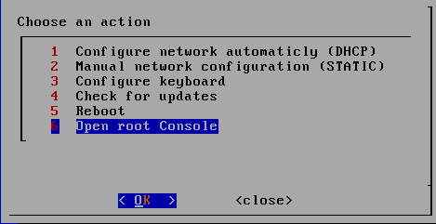
# sudo apt-get install vlc
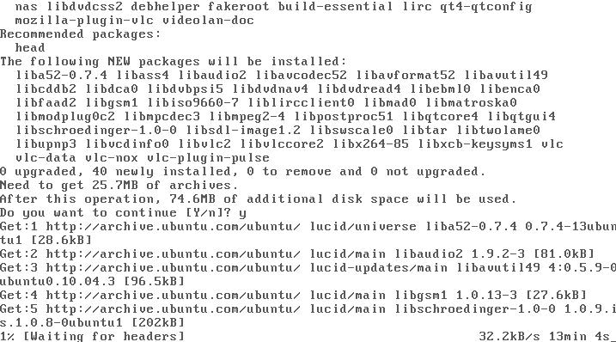

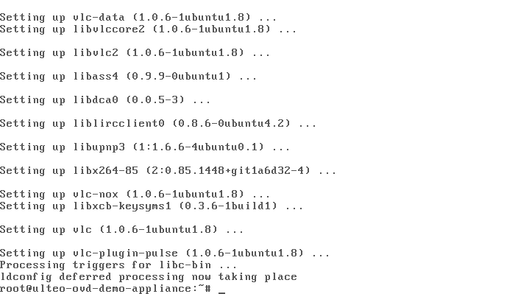
c. Go back to Administration console and add the static application (eg. vlc player)
Note: The application can be provided to users by assigning it to the user groups.
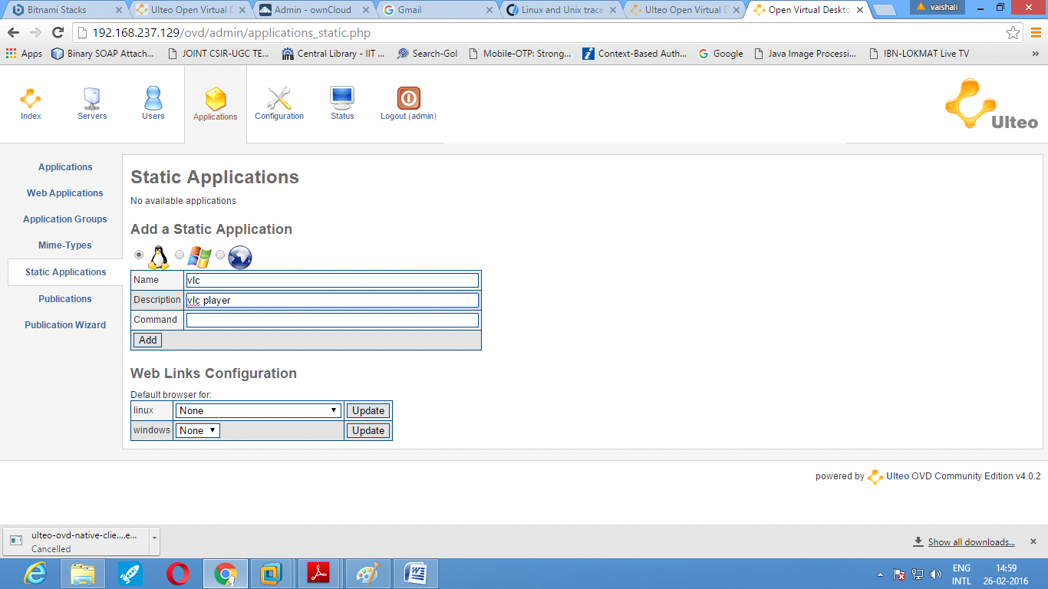
Step 12:
Login into the user console and access the Open Virtual Desktop provided by Ulteo. The application added at the server through the administrator console will be available to the users along with already exixting applications in the application group.
CONCLUSION:
Ulteo Open Virtual Desktop (OVD) is a delivery platform that provides on-demand access to private and public cloud hosted virtual desktops.

Program  Execution/  formation/  correction/  ethical practices  (07) | Documentation  (02) | Punctuality  (01) | Viva Answer  (05) | Experiment  Marks (15) | Teacher Signature with date

